The M·Tender data model for the establishment of Framework Agreements

Contents

Introduction 3

Objectives of this work 3

The OCDS contracting process life-cycle 3

The EU public procurement value-chain phases 4

Mapping OCDS and EU procurement life-cycles 5

Establishment and implementation of Framework Agreements 5

Scope 7

About the eForms 8

About the ePO 8

The Tender data model 8

Conventions 9

OCDS Tender: Conceptual Model Diagram 9

M·Tender Framework Agreement Conceptual Model Diagram 11

Interpretation of the diagram 11

Framework Agreements used for all the lots of the procedure 12

Class and properties: description tables 12

OCDS Release Related Processes and M·Tender Framework Agreements 15

Worked examples 16

JSON 16

RDF-based (Turtle) 20

Code Lists for eProcurement in the European Union 23

Terminology mapping 24

# Introduction

This document is part of the initiative M·Tender. M·Tender is a full digital service that supports public procurement from demand planning to payment for public contracts.

The MTender is a “multi‑platform networking digital procurement service it, comprise a government‑operated web portal and the Open Data central database unit and is networking with several commercial electronic platforms certified to support electronic tendering procedures for public sector and commercial clients”.

M·Tender, in turn, is based on the Open Contracting Data Standard (OCDS), which provides sound models and solutions for “the publication of structured information on all stages of a contracting process: from planning to implementation. The publication of OCDS data can enable greater transparency in public contracting, and can support accessible and in-depth analysis of the efficiency, effectiveness, fairness, and integrity of public contracting systems[1]”.

The Moldovan eProcurement scheme has adopted M·Tender and puts forward an extension to the OCDS aiming to model Framework Agreements in alignment to the more recent EU legislation and developments.

A repository with artefacts and documentation on the Moldovan eProcurement scheme and M·Tender, including this document, is publicly available for consultation and review[2].

## Objectives of this work

The present work aims at aligning the OCDS data model used in M·Tender to the information requirements annexed to the European Commission Implementation Regulation (EU) 2019/1780 (eForms[3]) and the latest version of the eProcurement Ontology (ePO[4]).

Additional objectives are:

* To provide a comparative illustration of the procurement life-cycle as conceived in OCDS and in the ePO.
* The provision of a mapping of the terminologies used in OCDS, eForms and ePO.

## The OCDS contracting process life-cycle

OCDS defines the contracting process as “*all the planning, tendering information, awards, contracts and contract implementation information related to a single initiation process*”.

OCDS approaches the public procurement from a process-oriented perspective. Each process includes input and output information resources (interrelated data) that are modelled, packaged and published in successive releases. These processes and resources cover[5]:

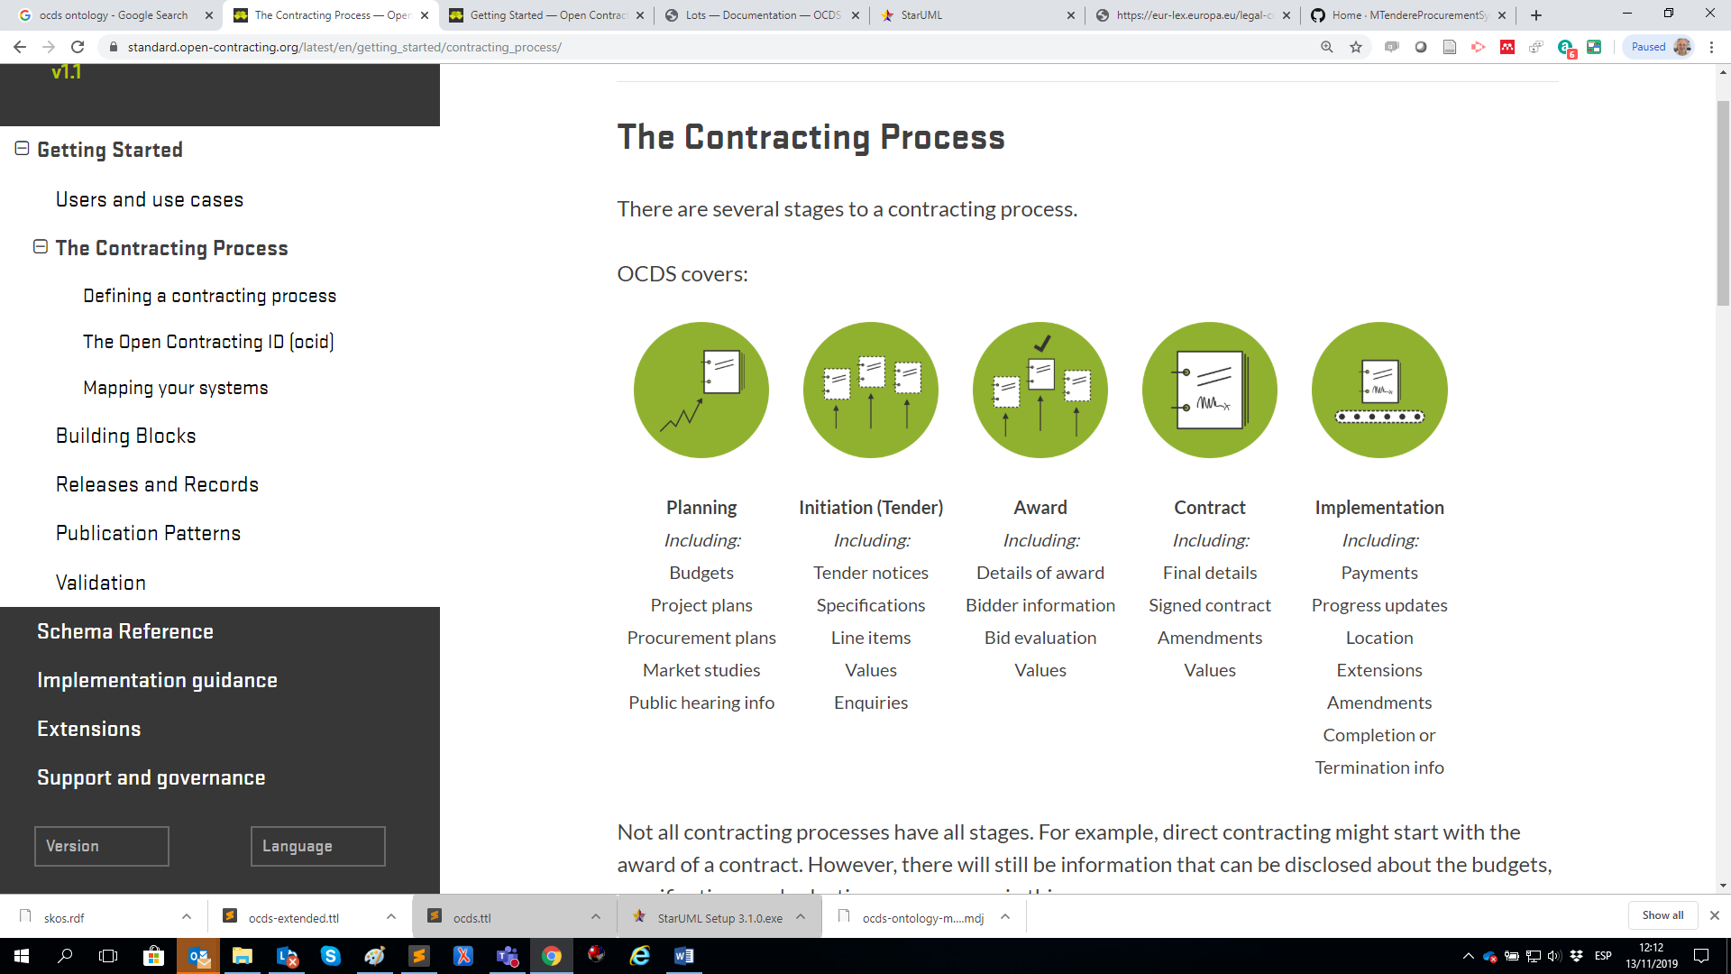

Figure 1: The OCDS Contracting Process stages (source: OCDS v1.1)

The majority of OCDS information (i.e. interrelated data) is held within a release structure. One or more releases can be published within a release package. Releases are made up of a number of sections, arranged in the following structure:

* Package
  + Release
    - Parties
    - Planning
    - Tender
    - Award
    - Contract
      * Implementation

## The EU public procurement value-chain phases

In the European Union the public procurement is rather perceived as and administrative “procedure” that includes contracting one or several suppliers (contractors) and managing and controlling the fulfilment of the contract.

The eForms equivalent entity for the OCDS “Contracting Process” is the data *business group[6]* “BG-6 Procedure”, which ePO defines as “A legally defined set of administrative activities conducted to conclude one or more contracts”.

The vision of the public procurement value chain is sometimes presented as follows:

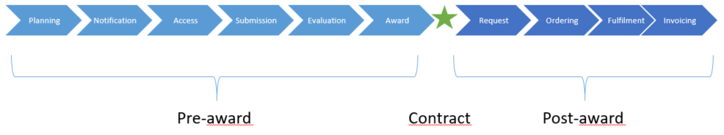

Figure 2: the public procurement value chain, EU’s vision

## Mapping OCDS and EU procurement life-cycles

A quick comparison of the OCDS and EU stages to procurement makes conspicuous that both models cover the same topics, at least from a high-level perspective:

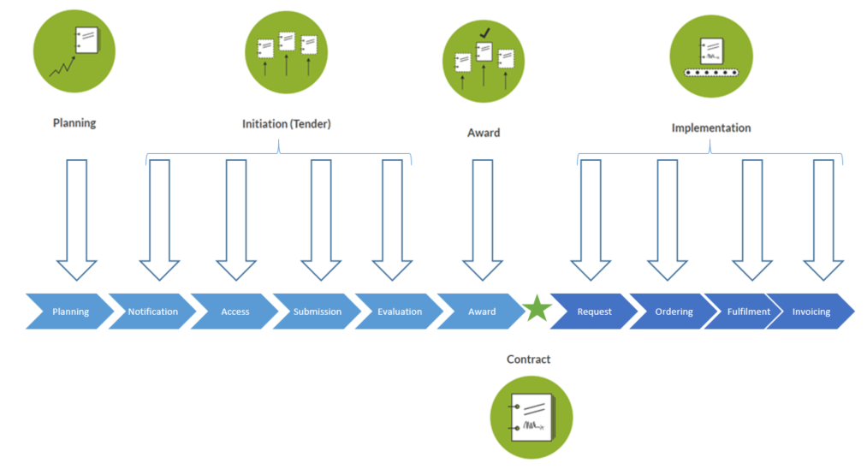

Figure 3: rough comparison between the OCDS and the EU public procurement life-cycle visions

## Establishment and implementation of Framework Agreements

In M·Tender, the business capabilities required regarding the establishment and implementation of Framework Agreements are modelled as very fine-grained BMPN models. Thus, the overall BMPN diagram for Framework Agreements looks like this:

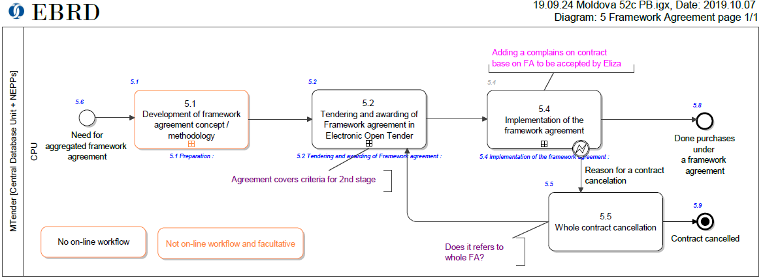

Figure 4: Main Framework Agreement-related activities

And the “preparation” activity (inside step 5.1) covers the following sub-processes:

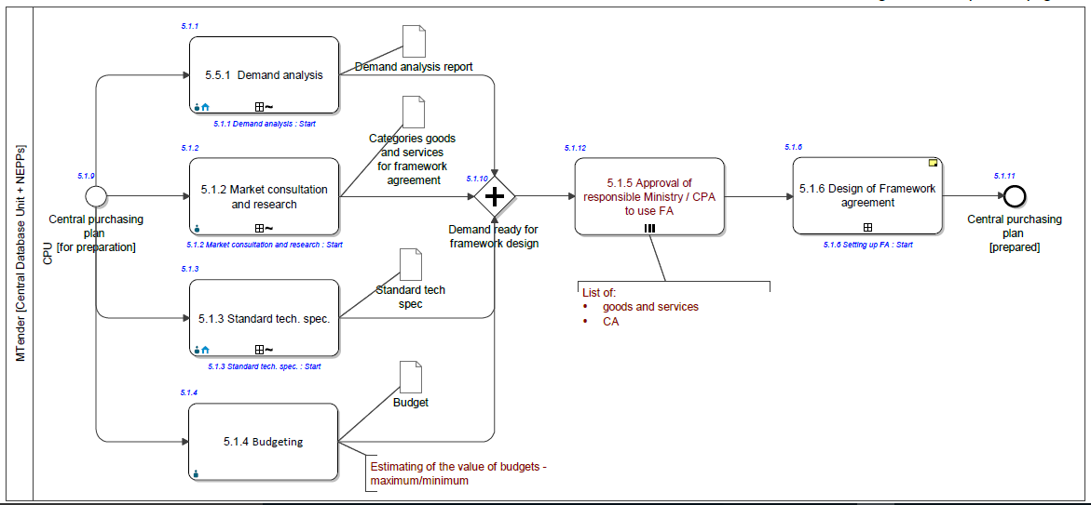

Figure 5: sub-activities of the Framework preparation process

The sub-sub-process 5.1.6 tackles the “design” of the Framework Agreement:

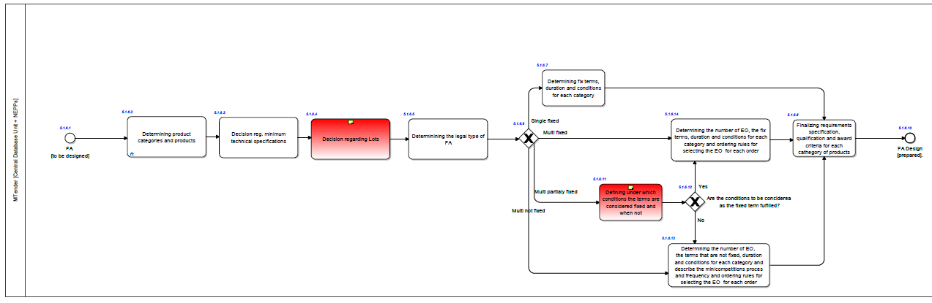

Figure 6: sub-activities in the sub-sub-process “design” of the Framework Agreement.:

## Scope

The alignment pursued focuses exclusively in the modelling of the information requirements related to **Framework Agreements** during the stage of **Initiation** (Tender). The reasons to limit the scope to this phase of the procurement procedure life-cycle are:

1. eForms does only cover the phase of eNotification, at planning and competition time.
2. ePO has only covered the phases of eNotification and eAccess.

The focus on modelling only Framework Agreements lies in the fact that the OCDS does not provides an extension covering this procurement technique. Hence M·Tender requests explicitly the development of the process and data models to develop the business and technical capabilities needed to implement Framework Agreements.

Therefore, the data modelled in this document cover notably the information requirements identified in the business process and sub-processes of the Framework Agreement preparation activity “5.1 Framework Agreement Preparation” and, as a matter of fact, they should be the outcome of that activity and should constitute the input of the following activities “5.2 Tendering and awarding of Framework Agreement” and “5.4 Implementation of the Framework Agreement”[7].

Hence the scope of the current work only covers the data between activities 5.1 and 5.2. The current evolution of the ePO – an ongoing work— will provide more insight on how this data model could be evolved to cover also the outcomes of the activity 5.4.

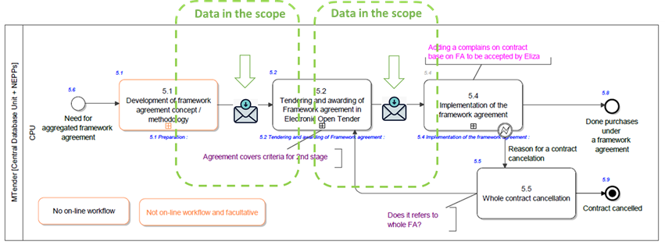

Figure 7: Data in the scope of this work and in the context of the BMPN model.

# The Tender data model

This section provides two diagrams:

* The data model containing the OCDS core building blocks and extensions; and
* The M·Tender extension proposed for announcement of the Framework Agreement

## Conventions

**Waver**

The representations of the OCDS data model provided herein are not normative nor endorsed by OCDS, but are mere proposals of the author of this document on how the reference Release and Building Blocks listed in the OCDS v1.1 site can be represented.

The following conventions apply to both diagrams.

In this representation cardinalities are not indicated but can easily inferred from the naming of the property. Thus an object property like *hasClassification* is to be understood as *0..1*, whilst the cardinality of *hasAdditionalClassifications* would be *0..n*. This principle appplies also to data properties (class attributes) such as *tender.id*, *tender.status*, *item.quantity*, *item.unit*, etc. (cardinality *1* when “Required” and cardinality *0..1* when “Recommended” or “Optional”. The assignment of whether a class attribute (mostly data properties) is Required, Recommended or Optional is a suggestion by the author of this document and it is not normative.

When citing main concepts represented in the diagrams or defined in eForms and ePO, the terms used to label those concepts will be always capitalised, i.e. the first letter of each word will be written in capital case, as in Procurement Procedure, Economic Operator, Tender, Tenderer, etc.

When existing, the names of the data and object properties are taken from the TBFY ontology[8] (e.g. in the triple *Tender hasProcurementMethod Code* – a code taken from the method code list—, the attribute used in the class is named *procurementMethod* and the predicate between entities is *hasProcurementMethod*). See diagrams below for more examples.

Notice also that the diagrams distinguish several types of entities:

1. “OCDS core building blocks” model classes (prefix *ocds:*, yellowish boxes, which are classes defined in the namespace of OCDS);
2. “OCDS Core extensions[9]” (prefix *ocds-ext:*, represented as blueish boxes), which are maintained by OCDS as part of their standard governance process);
3. “M·Tender extensions” (prefix *mt:* represented also as grayish boxes), which are proposed for the M·Tender platform and should become candidates for OCDS to be adopted;
4. “Enumerations” (sterotype *<<enumeration>>*, green boxes, which represent code lists).

## OCDS Tender: Conceptual Model Diagram

OCDS defines Tender as “*An open competitive bidding or tendering to form contracts. The process generally involves publicly inviting prospective contractors to submit bids for evaluation and selecting a winner or winners*”.

It also refers to the Tender part of the release as the section that includes “*details of the announcement that an organization intends to source some particular goods, works or services, and to establish one or more contract(s) for these. It can contain details of a forthcoming process to receive and evaluate proposals to supply these goods and services, and can also be used to record details of a completed tender process, including details of bids received*”. See the section “Initiation Type” in the OCDS official site[10] for all the details.

The diagram below shows a UML representation of the current OCDS data model (v1.1) of “Tender”. This diagram maps the classes and attributes documented via description tables in

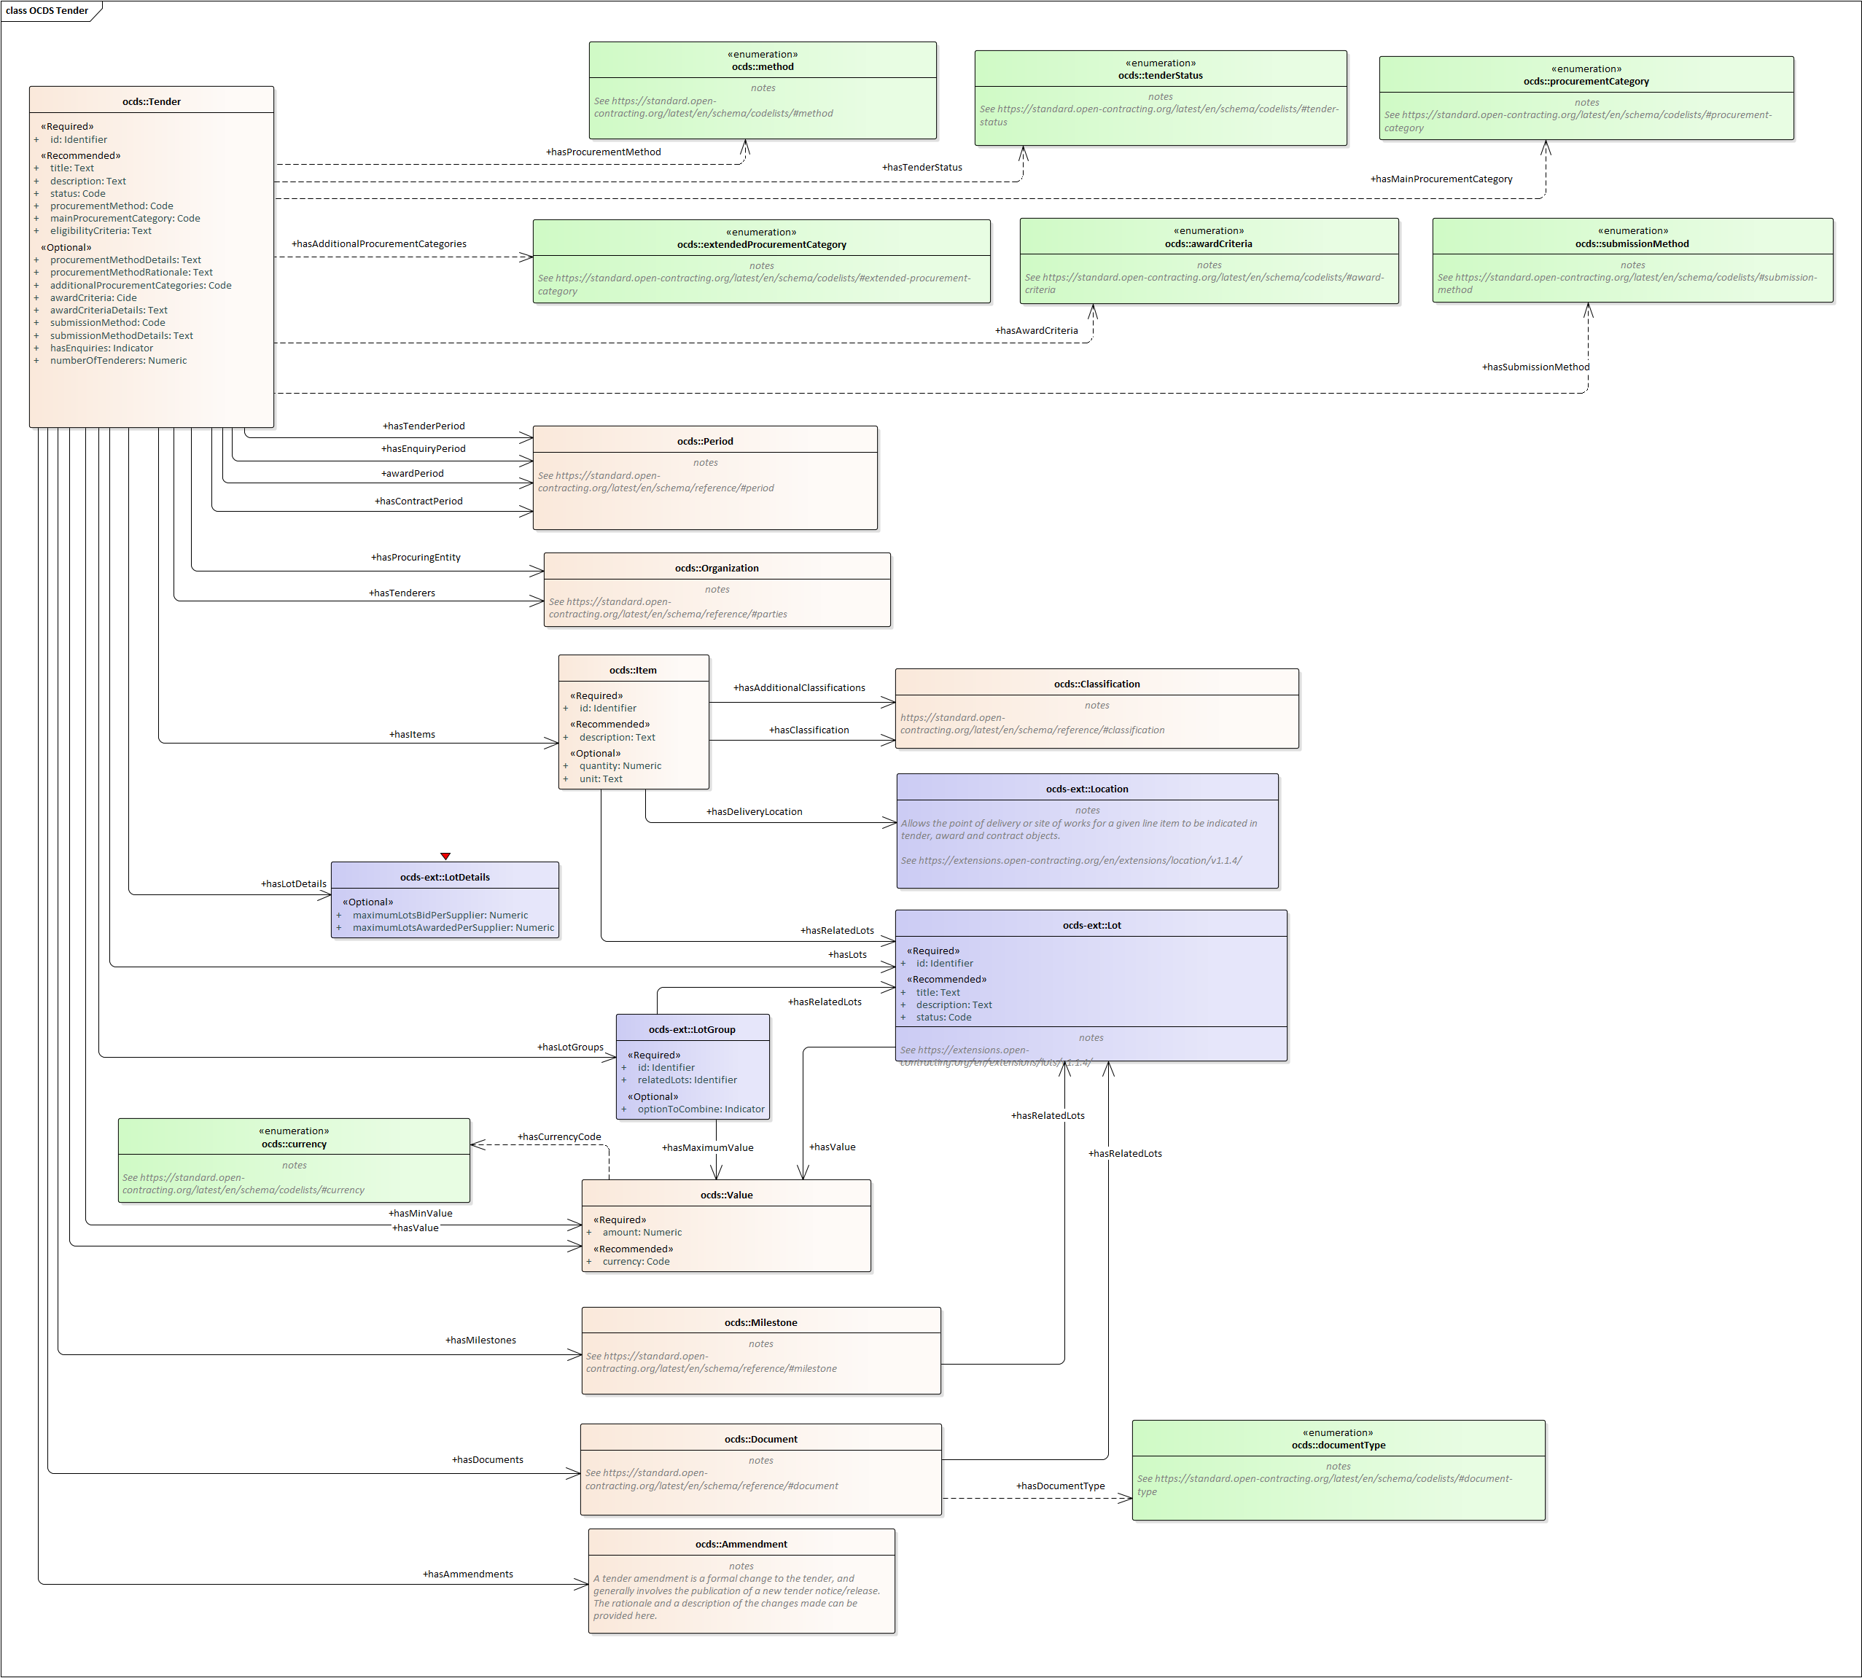

Figure 8: OCDS Tender Conceptual Model Diagram (OCDS extensions included)

## M·Tender Framework Agreement Conceptual Model Diagram

This work puts forward that the current OCDS model be extended with the work resulting from the ePO (for the phases of eNotification and eAccess). The ePO GitHub[11] repository contains the materials needed to check how the ePO design works and to compare how it has been adapted and integrated in M·Tender. Nonetheless, where notable differences are introduced, comments explaining the differences are provided.

The figure below shows the OCDS data model extended with the classes and properties needed in relation to the Framework Agreement for the Initiation Phase. Beware that the Award and Contract stages do also need take in and process data about the Framework Agreement. However, the current work does not cover those phases, as eForms does not cover them and ePO has not gone through that analysis, yet.

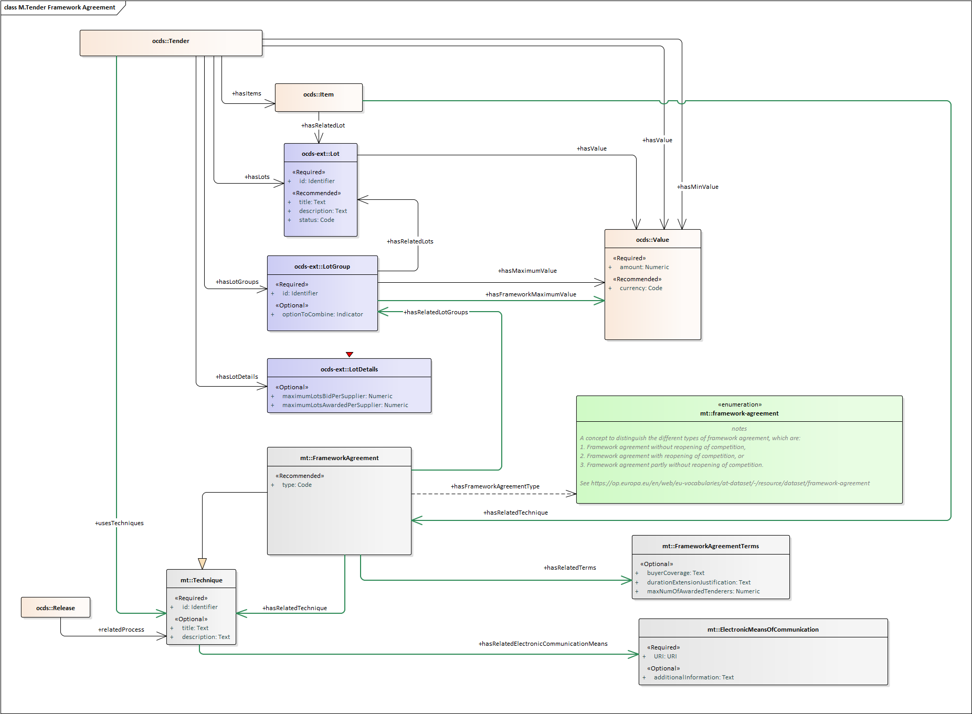

Figure 9: The M·Tender Framework Agreement proposal (at the Initiation stage)

### Interpretation of the diagram

In ePO Framework Agreements are “techniques” associated to a “Lot” or to “Groups of Lots”. The proposal for M·Tender is that a Technique may be referred to from the *ocds:Item* class. In doing this, the Technique is indirectly associated to one Lot, as in ePO.

At the notification time (Initiation, in terms of OCDS), the Framework Agreement (FA) does not exist as a Contract yet (the implementation starts with the Contract). The only information available at that moment are the “Terms” provided by the buyer[12]. This is why in the diagram below classes such as Contract and Purchase Contract (i.e. specific contracts within a FA) are not represented. Some techniques may use other techniques. Thus the Framework Agreement may use in turn eAuctions. A Technique provides one electronic means of communication for the buyer and the economic operators to communicate amongst themselves. As Framework Agreements and eAuctions are both descendants of the class *mt:Technique* they both inherit the property *mt:hasRelatedCommunicationsMeans*.

Notice that the class *FrameworkAgreementTerms* is associated to the Tender and referred to from the *FrameWorkAgreement* class. This design allows to define one set of terms for different framework agreements.

The Framework Agreement can be classified as:

1. Framework agreement without reopening of competition,
2. Framework agreement with reopening of competition, or
3. Framework agreement partly without reopening of competition.

The Publications Office of the European Union (OP) provides this code list in different formats publicly available at the EU Vocabularies site[13].

### Framework Agreements used for all the lots of the procedure

In ePO the decision was made that procurement procedures not divided into lots have to define at least one lot. In those cases, everything that is said for the lot applies to the whole procedure.

For the M·Tender, the Tender class aggregates as many Framework Agreements as needed by several Tender.Items. This design allows also to define one Framework agreement and refer to it from all the Items.

Therefore, in M·Tender, when the procedure uses only one Framework Agreement and is not divided into Lots, only one Item and one Framework Agreement are added to the OCDS class Tender, and the Item refers to the Framework Agreement. See example in JSON below for a reference implementation of this situation.

### Class and properties: description tables

#### Item

OCDS core building block. For M·Tender, the proposal is that the OCDS Technique be extended with the property *mt:hasRelatedTechnique*. Two techniques can be used for each Item, Framework Agreements and eAuctions. Furthermore, within a Framework Agreements an eAuction technique can also be used (see property *relatedTechnique* inside the class *FrameworkAgreement*.

The table below describes only the property *relatedTechnique*. For the rest of elements of the OCDS core building block Item see the official documentation[14].

|  |  |  |  |
| --- | --- | --- | --- |
| **Title** | **Description** | **Type** | **Required** |
| relatedTechnique | | Identifier [string, int] | Required |
| Has Related Technique | A reference to the identifier of a Framework Agreement or an eAuction. | | |

#### Framework Agreement

Taken from the ePO. The terms governing contracts, reached between one more buyers and one or more economic operators during a given period.

|  |  |  |  |
| --- | --- | --- | --- |
| **Title** | **Description** | **Type** | **Required** |
| Id | | Identifier [string, int] | Required |
| Framework Agreement ID | An identifier for this Framework Agreement. | | |
| Title |  | Text [string] | Recommended |
| Framework Agreement ID | A short text for the identification of the Framework Agreement. | | |
| Type | | Code [string] | Recommended |
| Framework Agreement Type | The type of the Framework Agreement, from the closed [framework-agreement](https://op.europa.eu/en/web/eu-vocabularies/at-dataset/-/resource/dataset/framework-agreement) codelist | | |
| relatedElectronicCommunicationMeans | | Object | Optional |
| Related Electronic Communication Means | Software solutions and electronic devices for communication and exchange of information between buyers and economic operators made available for a particular Framework Agreement. | | |
| relatedTechnique | | Object | Optional |
| Related Technique | A procurement Technique used by the Framework Agreement (FA), e.g. an eAuction in the context of the FA. | | |
| relatedLotGroups | | Object | Optional |
| Related Groups of Lots | Frameworks can be organised (and refer to) groups of lots. | | |
| relatedTerms | | Object | Optional |
| Related Framework Agreement Terms | Conditions and stipulations affecting this Framework Agreement. | | |

#### Framework Agreement Terms

Taken from the ePO. Theconditions and stipulations set for a particular for a Framework Agreement.

|  |  |  |  |
| --- | --- | --- | --- |
| **Title** | **Description** | **Type** | **Required** |
| Id | | Identifier [string, int] | Required |
| **Framework Agreement Terms Identifier** | An identifier for the terms of this Framework Agreement. | | |
| buyerCoverage | | Text [string] | Optional |
| Buyer Coverage | Buyers that can use the Framework Agreement not mentioned by name. Additional Information: For example, "all hospitals in the Tuscany region”. | | |
| durationExtensionJustification |  | Text [string] | Optional |
| Duration Extension Justification | The justification for exceptional cases when the duration of the framework agreement exceeds the legal limits. Additional Information: Four years in the case of the general procurement Directive, seven years in the case of the defence Directive, and eight years in the case of the sectoral Directive. | | |
| maxNumOfAwardedTenderers | | Numeric [int] | Optional |
| Maximum Number of Awarded Tenderers | The maximum number of tenderers who may be awarded a contract within the framework agreement. | | |

#### eAuction

Taken from the ePO. A repetitive technique in which new prices, revised downwards, and/or new values concerning certain elements of tenders are bid on-line.

|  |  |  |  |  |  |
| --- | --- | --- | --- | --- | --- |
| **Title** | **Description** | | **Type** | | **Required** |
| Id | | | Identifier [string, int] | | Optional |
| eAuction ID | A short text for the identification of the eAuction technique. | | | | |
| Title |  | | Text [string] | | Recommended |
| eAuction Title | A short text for the identification of the Framework Agreement. | | | | |
| relatedElectronicCommunicationMeans | | | Object | Optional | |
| Related Electronic Communication Means | | Software solutions and electronic devices for communication and exchange of information between buyers and economic operators made available for a particular eAuction. | | | |

#### Electronic Means of Communication

Taken from the ePO. Software solutions and electronic devices for communication and exchange of information between buyers and economic operators. Lots may use ad-hoc electronic means of communication that are not generally available such as specific solutions for secure and dedicated communication or non-standard eCatalogues.

|  |  |  |  |
| --- | --- | --- | --- |
| **Title** | **Description** | **Type** | **Required** |
| Id | | Identifier [URI] | Required |
| Electronic Means of Communication ID | A short text for the identification of the means of communication. | | |
| additionalInformation |  | Text [string] | Recommended |
| Electronic Means of Communication Additional Information | Supplementary data about the means of communication. | | |

#### LotGroup

OCDS extension. In the case of Framework Agreements (FA), the groups of lots may need to indicate the estimated maximum value for that group in the context of the FA. This table below describes only this property. For the rest of details about the extension GroupLot please see the documentation on the OCDS site[15].

|  |  |  |  |
| --- | --- | --- | --- |
| **Title** | **Description** | **Type** | **Required** |
| Id | | Identifier [URI] | Required |
| Lot Group Identifier | The identifier of the group of lots. | | |
| frameworkMaximumValue |  | Object [Value] | Recommended |
| Framework Maximum Value | The maximum value which can be spent, in a framework agreement. Additional Information: In the case of groups of lots, this value can be lower than the sum of values of individual lots (e.g. when the same budget is shared for several lots). | | |

#### Value

OCDS core building block. Financial values should be published with a currency attached.

|  |  |  |  |
| --- | --- | --- | --- |
| **Title** | **Description** | **Type** | **Required** |
| Amount | | Numeric | Required |
| Amount | Amount as a number. | | |
| Currency |  | Code [string] | Required for financial values |
| Currency | The currency of the amount, from the closed currency codelist. | | |

#### Framework-agreement codelist

EU Vocabularies eProcurement codelist. The type of the Framework Agreement, from the closed [framework-agreement](https://op.europa.eu/en/web/eu-vocabularies/at-dataset/-/resource/dataset/framework-agreement) codelist, defined for eForms and ePO.

|  |  |
| --- | --- |
| **Code** | **Description** |
| fa-wo-rc | Framework agreement, without reopening of competition. |
| fa-w-rc | Framework agreement, with reopening of competition. |
| fa-mix | Framework agreement, partly without reopening and partly with reopening of competition. |
| None | None. |

## OCDS Release Related Processes and M·Tender Framework Agreements

Beware that OCDS model uses the properties Release.relatedProcess to refer to “*the details of related processes: for example, if this process follows on from one or more other processes, represented under a separate open contracting identifier (ocid). This is commonly used to relate mini-competitions to their parent frameworks or individual tenders to a broader planning process*”. See the OCDS official documentation[16] for more details.

In principle the M·Tender model, in alignment with the eForms and ePO, does not consider the Framework Agreements as separate contracting processes but as sub-methods within one “Procurement Procedure”. Which does not preclude the possibility of referring to the Framework Agreements defined in the M·Tender via the *Tender.FrameworkAgreement* from the Release. If that is the case then the identifiers of the *Release.relatedProcess* and of the referred Technique *Tender.FrameworkAgreement* object must be identical.

This is represented in the M·Tender Conceptual Data Model Diagram above with the link between the OCDS Release and the M·Tender Technique:

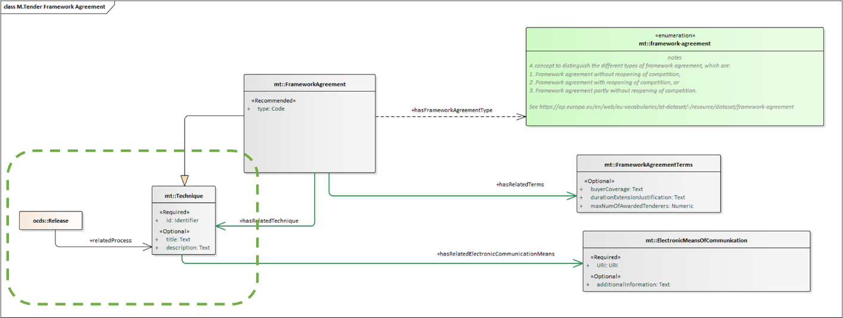

Figure 9: Reference to a Framework Agreement from the Release.

## Worked examples

### JSON

The JSON code below illustrates how to use the M·Tender model for Framework Agreements. The first example shows one Procurement Procedure that is not divided into lots and that uses the technique Framework Agreement. The second example illustrates the case of Procedure divided into three Lots and only Lot 1 and 2 are to be implemented using one Framework Agreement.

#### Example 1: procedure without Lots

|  |
| --- |
| {  "tender": {  "items": [  {  "id": "0001",  "description": "Architectural advice",  "classification": {  "scheme": "CPV",  "id": "71210000",  "description": "Advisory architectural services"  },  "relatedFrameworkAgreement" : "framework-agreement-1"  }  ],  "value": {  "amount": 1200000,  "currency": "GBP"  },  "frameworkMaximumValue" : {  "currency": "GBP",  "amount": 700000  },  "techniques": [  {  "id" : "framework-agreement-1",  "tag": "FrameworkAgreement",  "title": "ABC-IV, ICT for the EU institutions",  "type" : "fa-wo-rc",  "relatedElectronicCommunicationMeans" : "http://procplat.ca/comchannel/proc?id=20190123-abciv",  "relatedLotGroups" : [  {"relatedLotGroup" : "lot-group-1"}   ],  "relatedTerms": "framework-agreement-terms-1"  }   ],  "frameworkAgreementTerms" : {  "id" : "framework-agreement-terms-1" ,  "buyerCoverage" : "All the hospitals of the Tuscany region.",  "durationExtensionJustification" : "This FA is for two years, however the Directive 2014/24/EU allows for an additional extension of two other years (2 + 2)",  "maxNumOfAwardedTenderers" : 7  },  "electronicCommunicationMeans" : [  {  "id" : "http://procplat.ca/comchannel/proc?id=20190123-abciv",  "additionalInformation": "Use this channel also for questions and clarifications."  }  ]  } } |

Table 1: JSON Example of Procedure without Lots and one Framework Agreement

#### Example 2: procedure with lots

This other example is about a procedure divided into 3 lots, lot 1 and two grouped and under under a Framework Agreement contract, and lot 3 that does not uses any technique.

|  |
| --- |
| {  "tender": {  "items": [  {  "id": "0001",  "description": "Architectural advice",  "classification": {  "scheme": "CPV",  "id": "71210000",  "description": "Advisory architectural services"  },  "relatedLot": "lot-1",  "relatedFrameworkAgreement" : "framework-agreement-1"  },  {  "id": "0002",  "description": "Architectural design",  "classification": {  "scheme": "CPV",  "id": "71220000",  "description": "Architectural design services"  },  "relatedLot": "lot-1",  "relatedFrameworkAgreement" : "framework-agreement-1"  },  {  "id": "0003",  "description": "Civil engineering consultant",  "classification": {  "scheme": "CPV",  "id": "71311000",  "description": "Civil engineering consultancy services"  },  "relatedLot": "lot-2",  "relatedFrameworkAgreement" : "framework-agreement-1"   },  {  "id": "0004",  "description": "Structural engineering services",  "classification": {  "scheme": "CPV",  "id": "71312000",  "description": "Structural engineering consultancy services"  },  "relatedLot": "lot-3"  }  ],  "value": {  "amount": 1200000,  "currency": "GBP"  },  "lots": [  {  "id": "lot-1",  "title": "Architectural services",  "description": "For architectural services delivered in the project",  "status": "active",  "value": {  "currency": "GBP",  "amount": 200000  }  },  {  "id": "lot-2",  "title": "Civil engineering services",  "description": "For civil engineering services delivered in the project",  "status": "active",  "value": {  "currency": "GBP",  "amount": 400000  }  },  {  "id": "lot-3",  "title": "Structural engineering",  "description": "For structural engineering consultancy delivered in the project",  "status": "active",  "value": {  "currency": "GBP",  "amount": 600000  }  }  ],  "lotGroups": [  {  "id": "lot-group-1",  "relatedLots": [  "lot-1",  "lot-2"  ],  "optionToCombine": true,  "maximumValue": {  "currency": "GBP",  "amount": 1000000  },  "frameworkMaximumValue" : {  "currency": "GBP",  "amount": 700000  }  }  ],  "lotDetails": {  "maximumLotsBidPerSupplier": 4,  "maximumLotsAwardedPerSupplier": 2  },  "techniques": [  {  "id" : "framework-agreement-1",  "tag": "FrameworkAgreement",  "title": "ABC-IV, ICT for the EU institutions",  "type" : "fa-wo-rc",  "relatedElectronicCommunicationMeans" : "http://procplat.ca/comchannel/proc?id=20190123-abciv",  "relatedLotGroups" : [  {"relatedLotGroup" : "lot-group-1"}   ],  "relatedTerms": "framework-agreement-terms-1"  }   ],  "frameworkAgreementTerms" : {  "id" : "framework-agreement-terms-1" ,  "buyerCoverage" : "All the hospitals of the Tuscany region.",  "durationExtensionJustification" : "This FA is for two years, however the Directive 2014/24/EU allows for an additional extension of two other years (2 + 2)",  "maxNumOfAwardedTenderers" : 7  },  "electronicCommunicationMeans" : [  {  "id" : "http://procplat.ca/comchannel/proc?id=20190123-abciv",  "additionalInformation": "Use this channel also for questions and clarifications."  }  ]  } } |

Table 2: JSON Example of Procedure divided into Lots and one Framework Agreement

### RDF-based (Turtle)

The following fragments of code illustrates how the M·Tender model for Framework Agreements (again, just at the Initiation stage) may be implemented. This example takes the TBFY (They Buy For You[17]) T-Box and adds to it the classes and properties modelled in this document.

In our opinion codelists should not implemented in the same namespace for the ontology but should be external to it. Hence, differently from the TBFY implementation method of codelists we propose the externalisation of the different codelists and the use of the SKOS controlled vocabularies maintained by the Publications Office of the European Union (OP) and available from the EU Vocabularies site.

#### LotGroup

For the time being, TBFY does not provide a reference implementation for LotGroup, thus the prefix “mt:” representative of the M·Tender namespace:

|  |
| --- |
| ### <https://eprocurement.md/mtender/ontology/hasFrameworkMaximumValue>  ocds:hasMaximumValue rdf:type owl:DatatypeProperty ;  rdfs:domain ocds:LotGroup ;  rdfs:range ocds:Value ;  rdfs:isDefinedBy "OCDS extension schema v1.0.0: LotGroup extension." .  ### <https://eprocurement.md/mtender/ontology/hasFrameworkMaximumValue>  mt:hasFrameworkMaximumValue rdf:type owl:DatatypeProperty ;  rdfs:domain ocds:LotGroup ;  rdfs:range ocds:Value ;  rdfs:isDefinedBy "M·Tender schema v1.0.0: LotGroup extension." .  ### <https://eprocurement.md/mtender/ontology/lotGroupId>  mt:lotGroupId rdf:type owl:DatatypeProperty ;  rdfs:domain ocds:LotGroup ;  rdfs:range xsd:string ;  rdfs:isDefinedBy "M·Tender schema v1.0.0: LotGroup extension." .  ### <https://eprocurement.md/mtender/ontology/optionToCombine>  mt:optionToCombine rdf:type owl:DatatypeProperty ;  rdfs:domain ocds:LotGroup;  rdfs:range xsd:boolean ;  rdfs:isDefinedBy "M·Tender schema v1.0: LotGroup <optionToCombine>." .  ### <https://eprocurement.md/mtender/ontology/LotGroup>  mt:LotGroup rdf:type owl:Class ;  owl:disjointWith ocds:Tender, ocds:Lot ;  rdfs:isDefinedBy "M·Tender schema v1.0.0: LotGroup." ;  rdfs:comment "Based on the worked example provided by OCDS in https://extensions.open-contracting.org/en/extensions/lots/v1.1.4/" ;  rdfs:subClassOf [ rdf:type owl:Restriction ;  owl:onProperty ocds:hasLot ;  owl:allValuesFrom ocds:Lot  ] ;  rdfs:subClassOf [ rdf:type owl:Restriction ;  owl:onProperty ocds:hasMaximumValue ;  owl:allValuesFrom ocds:Value  ] ;  rdfs:subClassOf [ rdf:type owl:Restriction ;  owl:onProperty ocds:hasFrameworkMaximumValue ;  owl:allValuesFrom ocds:Value  ] ;  rdfs:comment "Uses also the following data type properties: optionToCombine." ;  rdfs:isDefinedBy "M·Tender v1.1: LotGroup." ;  ocds:usesDataProperty ocds:optionToCombine . |

Table 3:TTL definition of LotGroup

#### Framework Agreement

|  |
| --- |
| ### <https://eprocurement.md/mtender/ontology/FrameworkAgreement>  mt:FrameworkAgreement rdfs:subClassOf mt:Technique ;  rdfs:subClassOf [ rdf:type owl:Restriction ;  owl:onProperty ocds:hasRelatedLotGroups ;  owl:allValuesFrom mt:LotGroup  ] ,  [ rdf:type owl:Restriction ;  owl:onProperty ocds:hasRelatedTerms ;  owl:allValuesFrom mt:FrameworkAgreementTerms  ] ,  [ rdf:type owl:Restriction ;  owl:onProperty ocds:hasRelatedTechnique ;  owl:allValuesFrom mt:Technique ;  rdf:rdfs:comment "e.g. An eAuction within a FrameworkAgreement."  ] ,  [ rdf:type owl:Restriction ;  owl:onProperty ocds:hasRelatedCommunicationMeans ;  owl:allValuesFrom mt:CommunicationMeans  ];  rdfs:comment "Uses also the following data type properties: framworkAgreementId, title, frameworkAgreementType." ;  rdfs:isDefinedBy "M·Tender schema v1.0.0: FrameworkAgreement extension." ;  ocds:usesDataProperty mt:frameworkAgreementId ,  mt:frameworkAgreementType ,  dc:title . |

#### Framework Agreement Terms

|  |
| --- |
| ### <https://eprocurement.md/mtender/ontology/buyerCoverage>  mt:buyerCoverage rdf:type owl:DatatypeProperty ;  rdfs:domain ocds:FrameworkAgreementTerms ;  rdfs:range xsd:string ;  rdfs:isDefinedBy "M·Tender schema v1.0.0: FrameworkAgreementTerms extension." .  ### <https://eprocurement.md/mtender/ontology/durationExtensionJustification>  mt:durationExtensionJustification rdf:type owl:DatatypeProperty ;  rdfs:domain ocds:FrameworkAgreementTerms ;  rdfs:range xsd:string ;  rdfs:isDefinedBy "M·Tender schema v1.0.0: FrameworkAgreementTerms extension." .  ### <https://eprocurement.md/mtender/ontology/buyerCoverage>  mt:maxNumOfAwardedTenderers rdf:type owl:DatatypeProperty ;  rdfs:domain ocds:FrameworkAgreementTerms ;  rdfs:range xsd:positiveInteger ;  rdfs:isDefinedBy "M·Tender schema v1.0.0: FrameworkAgreementTerms extension." .  ### <https://eprocurement.md/mtender/ontology/FrameworkAgreementTerms>  mt:FrameworkAgreementTerms rdf:type owl:Class ;  rdfs:comment "Uses the following data type properties: buyerCoverage, durationExtensionJustification, maxNumOfAwardedTenderers" ;  rdfs:isDefinedBy "M·Tender schema v1.0.0: FrameworkAgreementTerms extension." ;  ocds:usesDataProperty mt:buyerCoverage ,  mt:durationExtensionJustification ,  dc:maxNumOfAwardedTenderers . |

#### ElectronicMeansOfCommunication

|  |
| --- |
| ### <https://eprocurement.md/mtender/ontology/ElectronicMeansOfCommunication>  mt:ElectronicMeansOfCommunication rdf:type owl:Class ;  rdfs:comment "Uses the following data type properties: URI, additionalInformation" ;  rdfs:isDefinedBy "M·Tender schema v1.0.0: ElectronicMeansOfCommunication extension." ;  ocds:usesDataProperty <http://schema.org/URL> ,  xsd:string . |

#### Technique and Tender

In RDF the Framework Agreement is modelled as a subclass of Technique. Hence:

1. The Tender class needs to be extended to include the reference to the techniques;
2. Framework Agreements may use additional Techniques, e.g. eAuctions,
3. Any Technique has access to a means of communication as they inherit it from their base class Technique.

|  |
| --- |
| ### <https://eprocurement.md/mtender/ontology/Technique>  mt:Technique rdf:type owl:Class ;  rdfs:comment "Uses also the following data type properties: techniqueID, title, description." ;  rdfs:isDefinedBy "M·Tender schema v1.0.0: Technique extension." ;  ocds:usesDataProperty mt:techniqueID, dc:title, dc:description .  ### The OCDS Tender needs to be extended with the reference to the Techniques.  ### https://theybuyforyou.eu/ontology/ocds/Tender  ocds:Tender rdf:type owl:Class ;  rdfs:subClassOf [ rdf:type owl:Restriction ;  owl:onProperty ocds:hasReleatedTechnique ;  owl:allValuesFrom ocds:Technique], …. etc. (see the example in the M·Tender GitHub). |

# Code Lists for eProcurement in the European Union

[TODO]

* Refer to the fact that an effort is on-going to align the code lists used for eProcurement at the EU level;
* Mention (and include the reference to) the EU Vocabularies and the collection of controlled vocabularies “eProcurement”;
* One Source of Vocabularies: mention that this effort is aligning eForms, ePO, ESPD and eCertis, and that at some point (not far away) these three initiatives will use only the vocabularies published by OP.

|  |  |  |  |
| --- | --- | --- | --- |
| **OCDS term** | **OCDS code list** | **eForms/ePO code-list** | **Comments** |
| ocds:Tender.procurementMethod | [method](https://standahttps:/standard.open-contracting.org/latest/en/schema/codelists/#method) | [procurement-procedure-type](https://op.europa.eu/en/web/eu-vocabularies/at-dataset/-/resource/dataset/procurement-procedure-type) |  |
| ocds:Tender.status | [tenderStatus](https://standard.open-contracting.org/latest/en/schema/codelists/#tender-status) | N/A | This is controlled otherwise, e.g. Notices may indicate that the procedure has been "Terminated". |
| ocds:Tender.procurementCategory | [procurementCategory](https://standard.open-contracting.org/latest/en/schema/codelists/#procurement-category) | [contract-nature](https://op.europa.eu/en/web/eu-vocabularies/at-dataset/-/resource/dataset/contract-nature) |  |
| ocds:Tender.extendedProcurementCategory | [extendedProcurementCategory](https://standard.open-contracting.org/latest/en/schema/codelists/#extended-procurement-category) | [contract-nature](https://op.europa.eu/en/web/eu-vocabularies/at-dataset/-/resource/dataset/contract-nature) |  |
| ocds:Tender.awardCriteria | [awardCriteria](https://standard.open-contracting.org/latest/en/schema/codelists/#award-criteria) | [award-criterion-type](https://op.europa.eu/en/web/eu-vocabularies/at-dataset/-/resource/dataset/award-criterion-type) |  |
| ocds:Tender.submissionMethod | [submissionMethod](https://standard.open-contracting.org/latest/en/schema/codelists/#submission-method) | N/A | eForms and ePO do not focus on how Tenders are submitted, the assumption is that "by electronic means", thus the "e" prefixing "Forms" and "PO". |
| N/A | N/A | [framework-agreement](https://op.europa.eu/en/web/eu-vocabularies/at-dataset/-/resource/dataset/framework-agreement) | Used to categorise the concrete type of FA. See EU Vocabularies site, collection "eProcurement". |
| ocds:Value.currency | <https://standard.open-contracting.org/latest/en/schema/codelists/#currency> | <https://op.europa.eu/en/web/eu-vocabularies/at-dataset/-/resource/dataset/currency> |  |

# Terminology mapping

In ePO and eForms, there is not a concept exactly equivalent to the OCDS Tender:

* in ePO the term “Tender” is always used to refer to the information submitted by the Economic Operator. By doing so, the Economic Operator adopts the role of a Tenderer. Hence the term Tender, as used in OCDS, may refer to releases containing data on the Procurement Procedure, the Procurement Documents and the Tender submitted by the Tenderer;
* In eForms the term Tender is used in the same sense that in ePO, but it is not defined as eForms does not cover the eSubmission phase.
* In, both, eForms and ePO, the “*details of the announcement”* (except for the Contract Award Notice) as well as other documents (e.g. specifications issued by the buyer in the eAccess phase) are termed “*Procurement Documents*”.

Amongst the artefacts provided jointly with this document there is a spread-sheet mapping elements between the OCDS Building blocks and extensions, the proposal for M·Tender and the equivalences in eForms and ePO. Beware that the spread-sheet does map only those elements related to the diagram on the M·Tender Framework Agreement at the Initiation Phase. The elements mapped are:

1. The terms used in the eForms Regulation and the correspondent terms in OCDS, M·Tender and ePO;
2. The definitions of the terms in OCDS, M·Tender, eForms and ePO;
3. Codelists used in OCDS and the correspondence with the ones used in EU.

The figure below provides a “collapsed” view of some of these elements (i.e. rows irrelevant for the M·Tender Framework Agreement have been hidden). The complete spread-sheet can be download from the M·Tender GitHub[18].

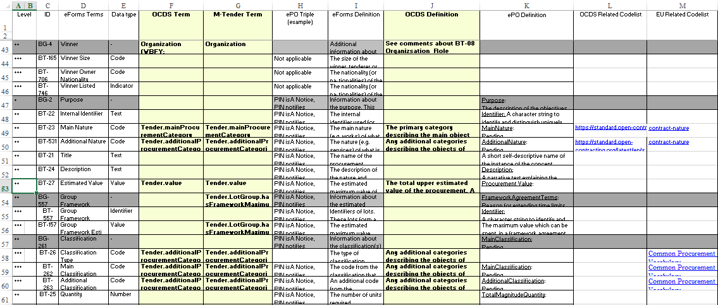

Figure 10: Example of mapping terms, definitions and codelists between OCDS, M·Tender, eForms and ePO

1. OCDS, getting started: <https://standard.open-contracting.org/latest/en/getting_started/>.
2. M·Tender repository of artefacts and documentation: <https://github.com/MTendereProcurementSystem/MTender/wiki>.
3. eForms Regulation: <https://eur-lex.europa.eu/eli/reg_impl/2019/1780/oj>.
4. ePO (eProcurement Ontology) GitHub: <https://github.com/eprocurementontology/eprocurementontology/wiki>.
5. The OCDS v1.1 stages to a contracting process: <https://standard.open-contracting.org/latest/en/getting_started/contracting_process/>.
6. In eForms a *business group* is a nested set of *business terms* (labels) that represent a concept used in the domain of the European Public Procurement. ePO maps the eForms business groups and business terms to classes and properties of an ontology.
7. See the M·Tender GitHub for exhaustive details on the BMPN models: <https://github.com/MTendereProcurementSystem/MTender>.
8. The TBFY (TheyBuyForYou) ontology: <https://github.com/TBFY/ocds-ontology>.
9. OCDS Extensions: <https://standard.open-contracting.org/latest/en/extensions/>.
10. OCDS site, section “Initiation Type”: <https://standard.open-contracting.org/latest/en/schema/codelists/#initiation-type>.
11. ePO GitHub: <https://github.com/eprocurementontology/eprocurementontology/wiki>.
12. In ePO, “Terms” are classes associated to Lot or Procedure use to group those “conditions or stipulations defining” a particular concept, e.g. Framework Agreement Terms, Procedure Terms, Design Contest Regime Terms, etc.
13. FA type code list, at OP’s EU Vocabularies: <https://op.europa.eu/en/web/eu-vocabularies/at-dataset/-/resource/dataset/framework-agreement>.
14. OCDS Item building block: <https://standard.open-contracting.org/latest/en/schema/reference/#item>.
15. OCDS extensions for Lots: <https://extensions.open-contracting.org/en/extensions/lots/v1.1.4/>.
16. OCDS Release.relatedProcess documentation: <https://standard.open-contracting.org/latest/en/schema/reference/#release> and <https://standard.open-contracting.org/latest/en/schema/reference/#relatedprocess>.
17. The TBFY (TheyBuyForYou) ontology: <https://github.com/TBFY/ocds-ontology>.
18. M·Tender Github, spread-sheet for the mapping of M·Tender to eForms and ePO: <https://github.com/MTendereProcurementSystem/MTender_Internal>.